b1 = 0.2, change a1:
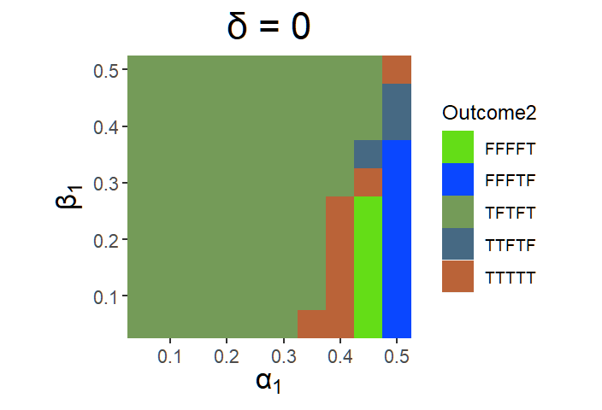
(1) a1 = 0.35
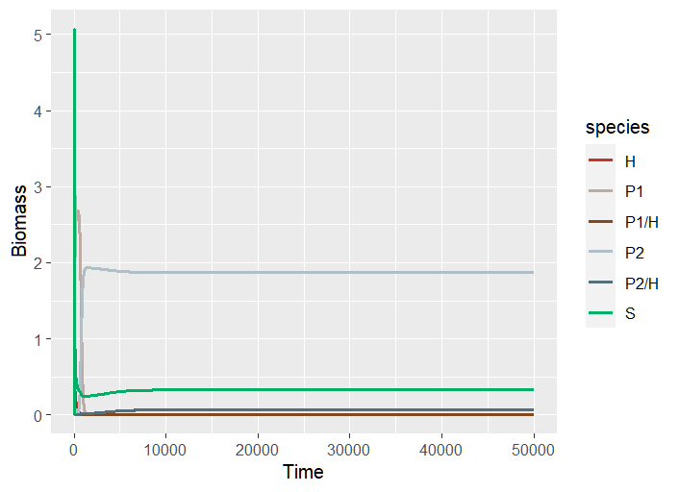
P2 and P2H win (TFTFT)
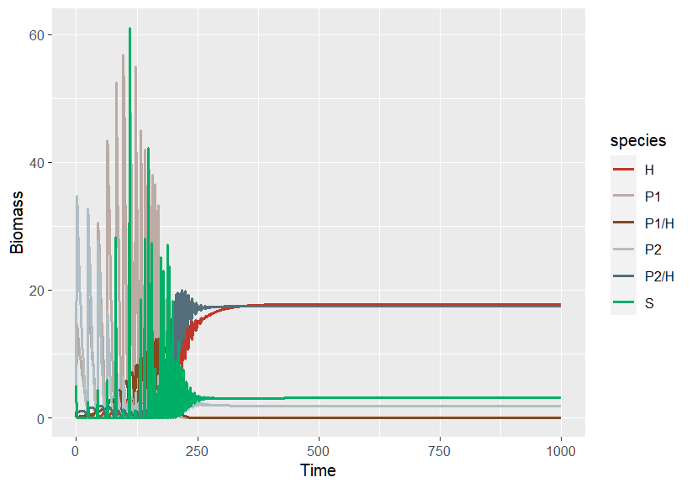
Set r = 10; K = 100; time = 0.01 -> P2 and P2H win.

(2) a1 = 0.4
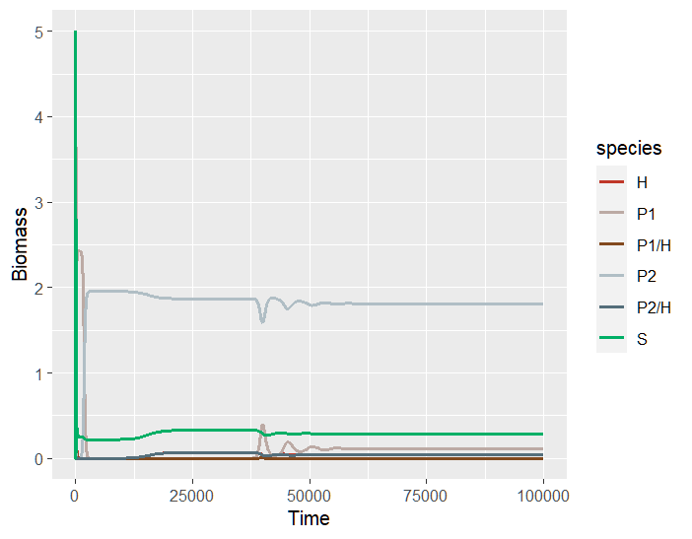
Coexist (TTTTT)

Time->0.01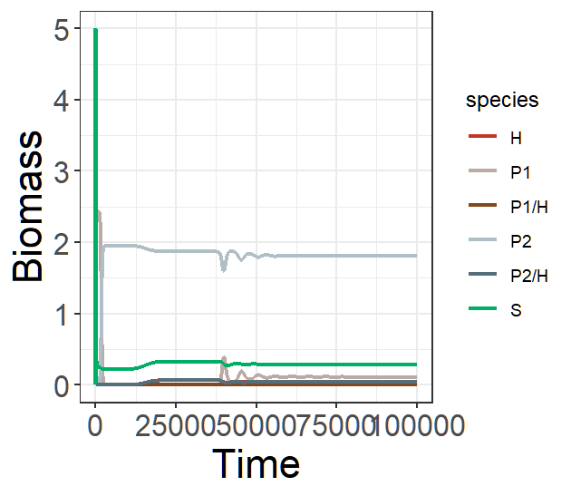 same! 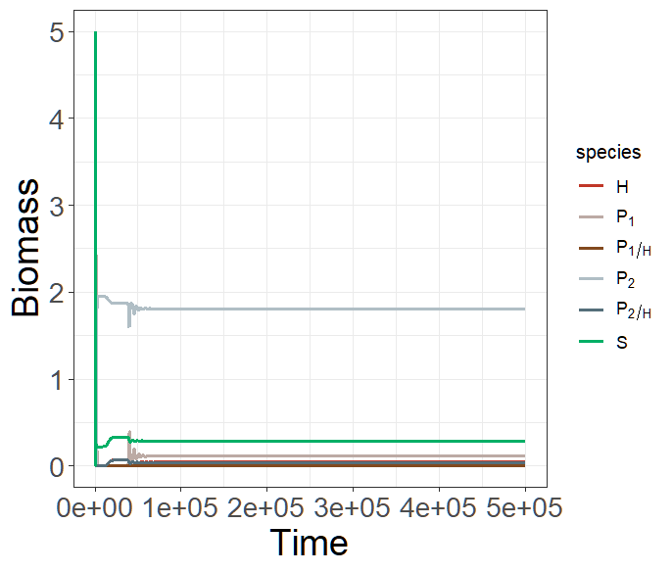跑到500000也沒cycle, 數值也沒變動。
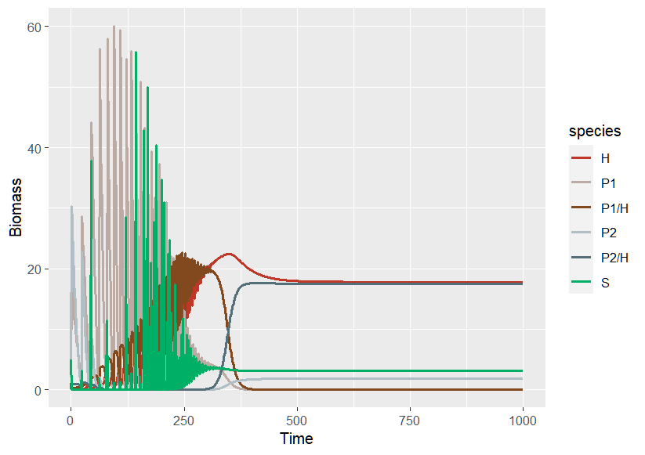
Set r = 10; K = 100; time = 0.01 -> P2 and P2H win.
Before adjusting r and K value, the abundance of P₁ is rather small when reach the equilibrium, however, is large enough to coexist with P₂. After make r and K larger value, the abundance of H subsequently increase, and this will decrease the abundance of P₁, because of the term (-β₁P₁H).

(3) a1 = 0.45
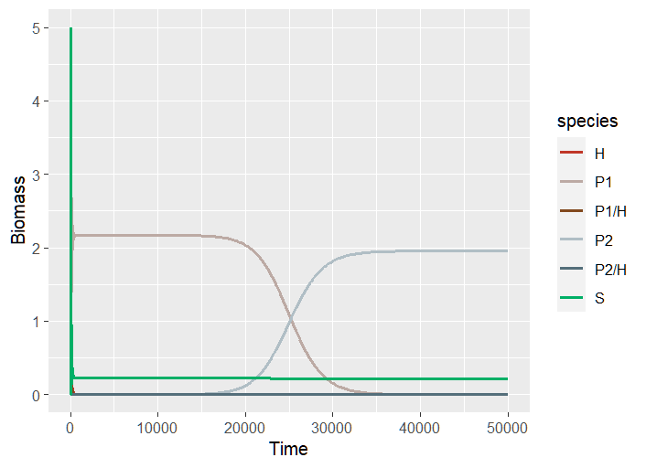
P2 win (no cycle) (FFFFT)
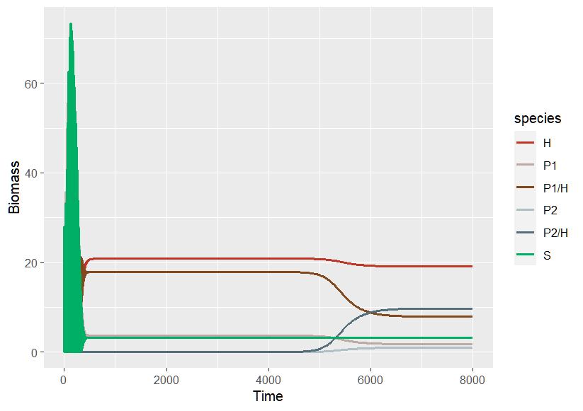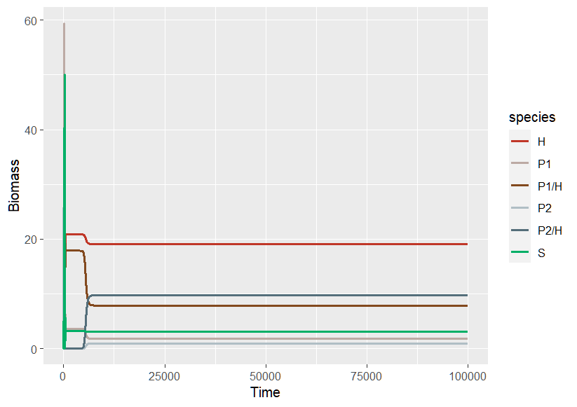
r = 10; K = 100; time = 0.01 -> coexist Why P2 can invade again? Because a1 < a2?
K=100; time = 0.01 的結果一樣 (因為r不夠大，S長不到那麼多)

(4) a1 = 0.5
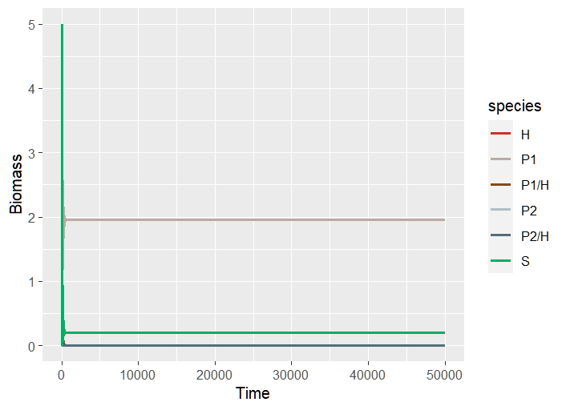
P1 win (FFFTF)

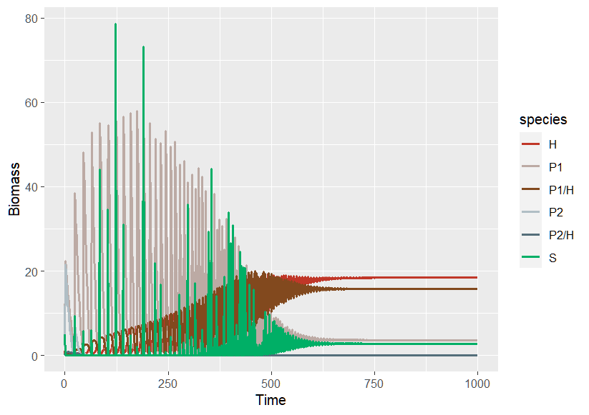
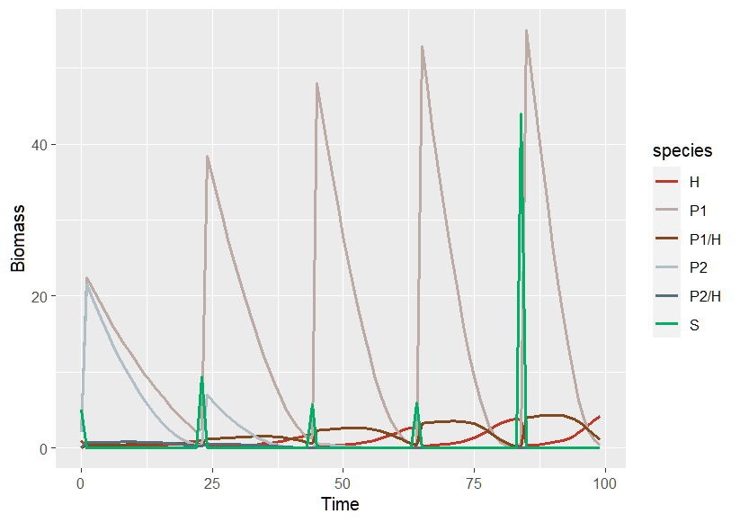
r = 10; K = 100; time = 0.01 -> P1 and P1H win.
Increasing K will make H can persist.
Because a1 = a2 and b1 < b2, P2 is a relatively weak competitor compared to P1. Therefore, P2 will be excluded in the first place.
P1 will take place, and because of sufficient resources, the abundance of P1 is large enough to persist H.

But when a1 < a2 and b1 < b2, the outcome would be coexistence.

When increasing β₂ from 0.45 to 0.5:
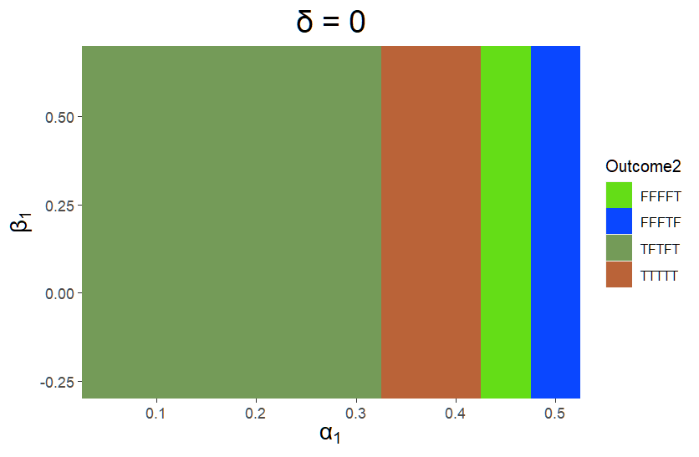
(There is a cycle when a1 = 0.4, b1 = 0.2)

When increasing β₂ from 0.45 to 0.6:
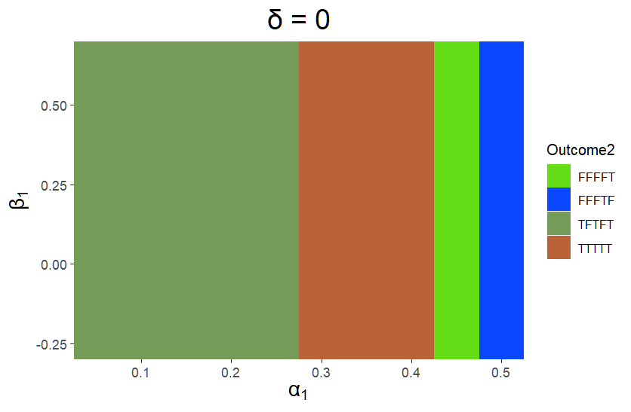
There is a cycle when a1 = 0.35, b1 = 0.2 and when a1 = 0.4, b1 = 0.2.

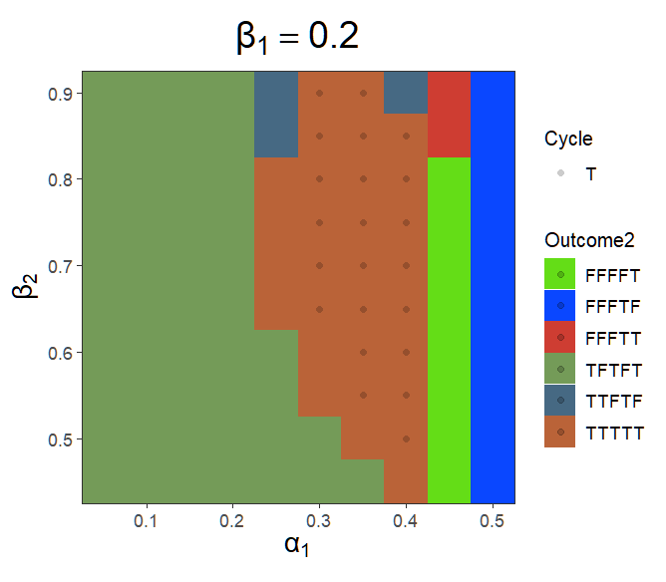
>>When α is low (<0.4) , an increase in β₂ can enhance the likelihood of coexistence within the system.
Because an increase in β₂ will make more P₂ become P_{2/H}, and thus decrease the abundance of P₂, the resource can be released, and P₁ can persist. Or one can say that because β₂ will make P₂ less competitive, P₁ will have a greater chance to invade and thus coexist.
It turns out that species will coexist.

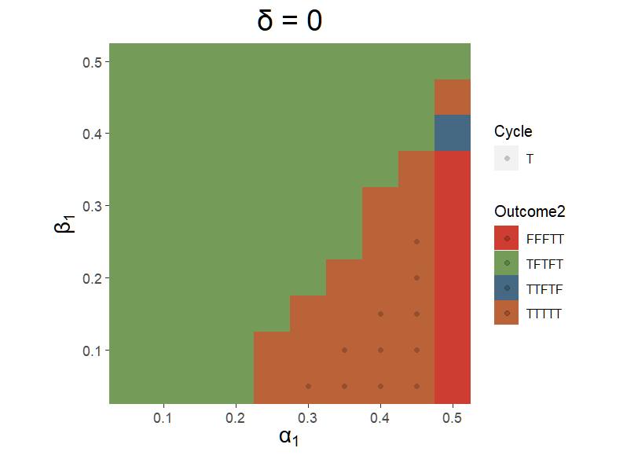

Pre1Sim2NC 放大左下角區塊。

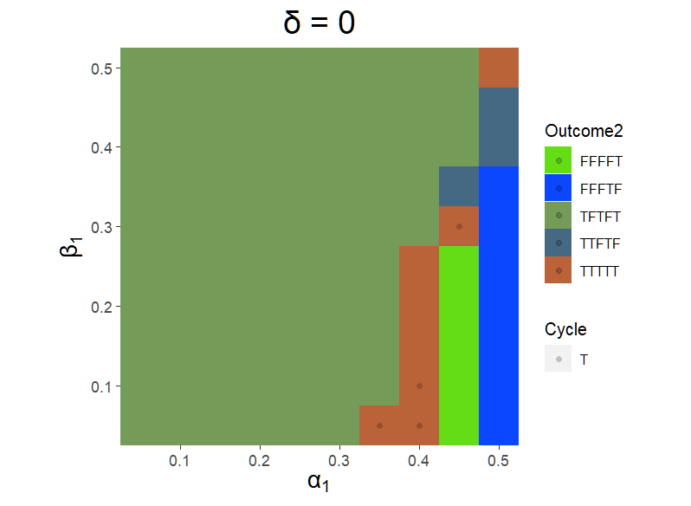
Pre1Sim3NC

